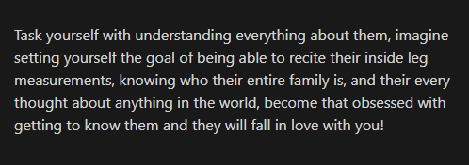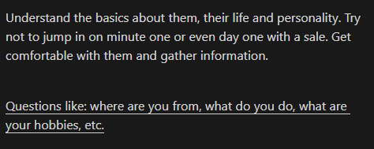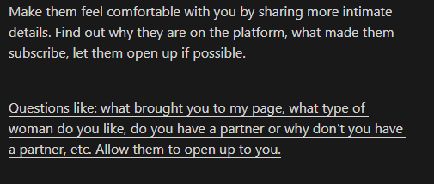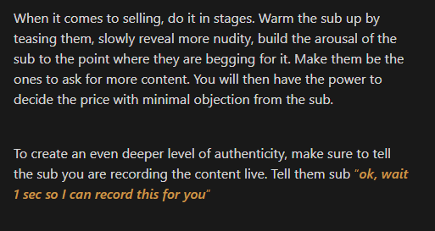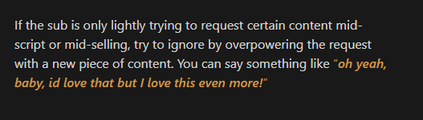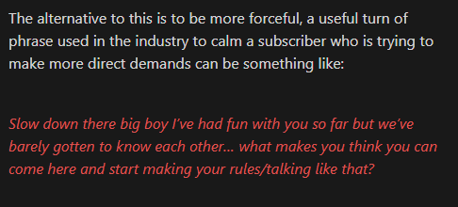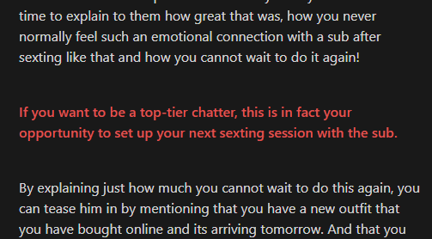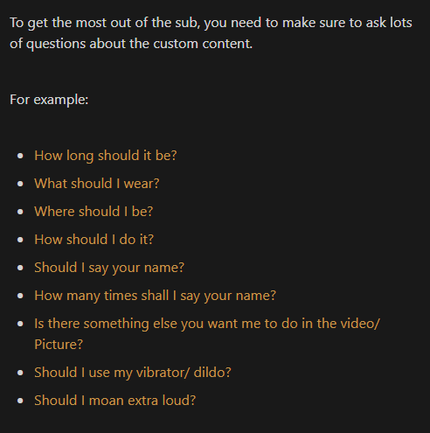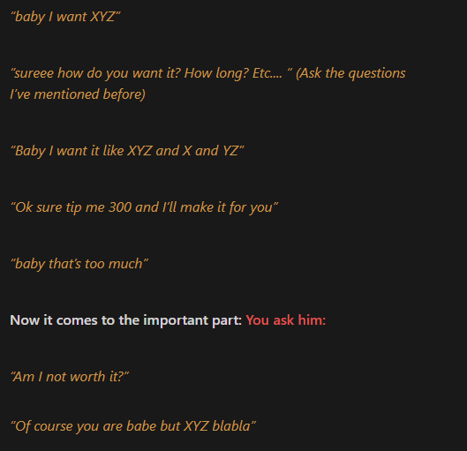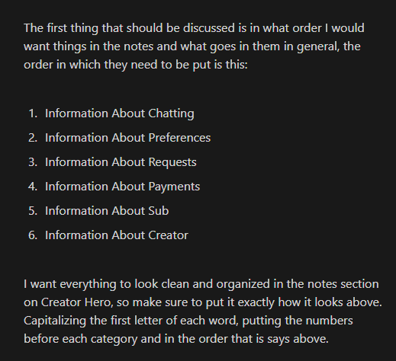

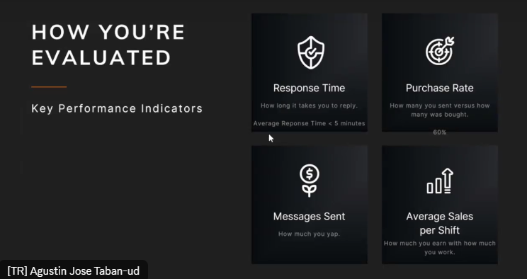

Payments= Monday CST thru WISE

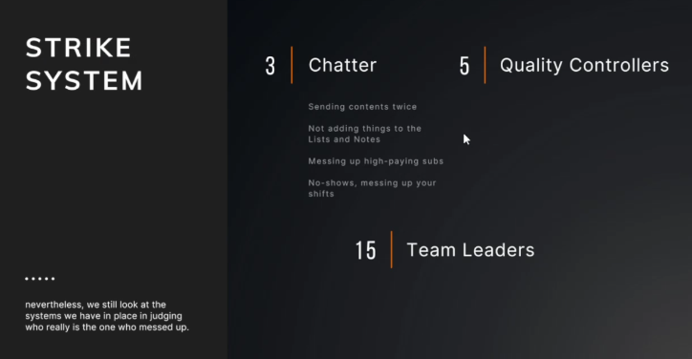  
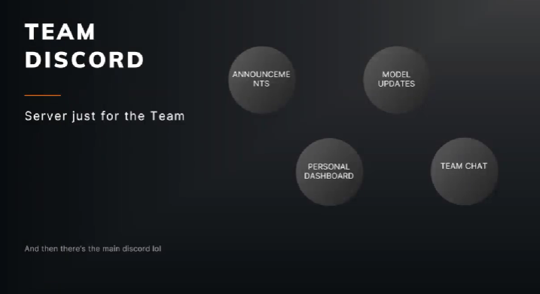

Creatorhero  
pinned post=  
message code  
notifications=look first on the comments, subscriptions/new subs, purchases, and tips

Collection=never touch. Unless you’re a qc/tl

Vault=where we store every contents we have. Have codes for the designated content

Messages= numbered for chatters. Chatters have numbers in their names for their conrresponding sub

Sub name title= number, emoji(assigned for roles), name/nicknames

Snow=higher roles

Clover=recently sent content

Pencil=read notes

Whale= spent $100+ (the guy might be loaded)

Hourglass= timewaster (ask qc bc they’re gonna look and edit it)

Star/sparkling= relationship building session

Pig nose=only buy ppv/might not want to talk

Reptile= same as pig, but pays more

Moneybag= spent 50-250

Unicorn= 250=1000

Angry emoji=0-5 none spenders

Bell= just set sexting set

Splash=cooltime  
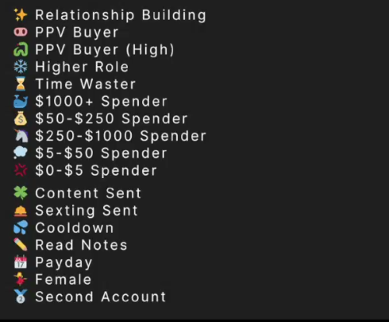

Calendar= payday sub

Time cst= we cut off the sub (the sub may be thinking we’re sleeping)/ think of it as an alarm

“Asking for” custom/code

Gallery: where we can see the content we’ve sent

The list: the content sent. To avoid sending it twice

Base price/min price: do not go lower.if sub ask for lower, ask qc but typically don’t lower it.

Notes:

\*info of the sub. All info we learned from them.

\*info about ‘us’

After saying any info abt us, put it immediately in the nsut offotes

Cut off/End chat= sub not spending money on us, then edit the CST to the title

Buttons= countdown, add media from vault, message price

Chatting strategies:

Buying signal: spending money right away as a new sub even before they get to know you

New sub = Send them reaching-out audio

Green flag ask for ppv, strategy: sell him sexting set

Relationship build, shows buying signal, add fillers,being playful is stil a part of a technique,